Diljit Bal (Ead 502)

Professor Roberson

DS 5003

17 Sept 2022

Exam 2

Question 1 – If I was one of the engineers behind PARiS, the interpretation of fairness I would lean towards is the concept of equal opportunity. I agree with the notion that all individuals should receive the same opportunity to showcase their merits and that individuals are placed under the principle of meritocracy. I don’t like the conception of fairness that is equality of outcomes because it removes the concept of individual merits and achievements and instead places everyone on an equal field. I can see and understand how that can be seen as fair, but the reality is that if you’re hiring someone to do a job that requires a specific skillset, wouldn’t it be the wise thing to review and see their abilities rather than just equally give jobs to those who are qualified and those who aren’t? Again, I can understand how this frame of thinking would apply in another scenario, like for example let’s say there’s a cake and you must serve 20 people, the fair thing here would be to equally divide the cake into 20 pieces and serve thus retaining fairness in cake size among the 20 individuals. It makes sense in that scenario because that situation doesn’t require any input/attributes from any of the individuals but let’s say the example changed and now I had to choose someone in the 20 people to bake a cake. Realistically, I wouldn’t want to choose from the 20 people randomly because what if I choose someone who has no idea to bake, that would just be inefficient. The best thing to do in that situation would be to ask the simple question “Can anyone here bake?”, determine that as a level of comparison/meritocracy, and move on from there. Moving on, again, while making sense in other situations, procedural, legal, and especially interpersonal conceptions of fairness don’t have a place in interpreting the fit of an employee in an organization as well. Interpersonal conceptions of fairness could be biased by nature of individual and thus have no place in a proper “fair” hiring process, and by default the hiring process is already monitored by the U.S. government in providing anti-discrimination laws, so the legal factor in fairness is already there. As a job applicant, I still believe that equal opportunity is the interpretation of fairness I lean on, and I come to that conclusion because as an applicant/job seeker, I’d want to get a job I know I can perform 100% and understand how to go about. I personally wouldn’t want to apply for a job, get it, and then find out I’m not a good fit for it because I am not qualified for the position, that just sounds like a waste of everyone’s time. I’d really prefer if someone (or even in this case, an AI) was to scan through my application and determine if I was a right fit for the workload and overall company culture rather than an application process where I got the job just because I applied. Sounds nice I know but as an individual I prefer systematic approaches to things and would like that to apply to my job application process as well.

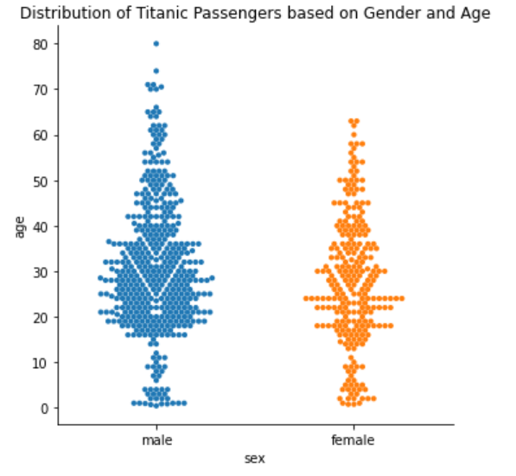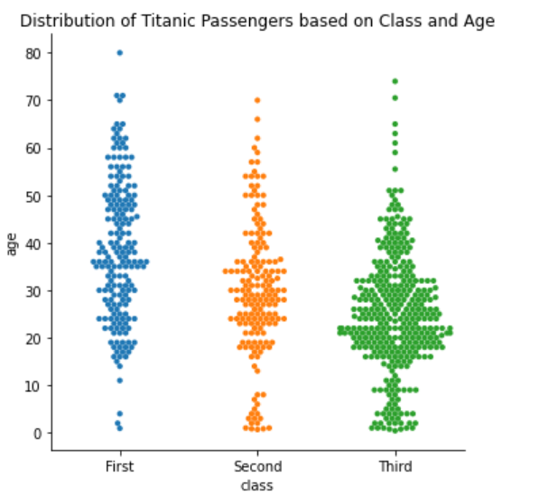Question 2 – Visualization

Question 3

The Titanic was a British passenger liner that, at the time of its inception (1912), was the largest ship afloat in the entire world. After its maiden voyage on April 10th, 1912, leaving from Southampton, England, the Titanic was sailing across the Atlantic Ocean on its way to New York City when unfortunately, on April 15, 1912, at 11:40 PM ship time, it drastically hit an iceberg, causing the ships hull to fill with water and ultimately leading to the sinking of the record-holding ship. Of the total amount of passengers, a question could be asked, with that question being “Who was the average individual to survive the sinking of the Titanic?”. Well, as shown on the graphs above, the average age of a Titanic passenger was roughly 30 years of age and there were almost twice as many men present on the ship compared to women. Of the classes onboard, Third-Class passengers vastly outweighed the amount of First and Second-Class passengers, with Third-Class containing almost (ironically) three times the number of passengers, compared to either First or Second-Class respectively. Much of the Third-Class passengers were also male (2-to-1 ratio of Men to Women in Third-Class) with the other 2 classes maintaining a similar level of men-to-women ratio in their respective classes. Looking at the survivability of the passengers onboard the Titanic, most of the passengers that unfortunately were not able to get on to an escape raft were disproportionately male as seen on the swarm plot describing “Survivability Based on Age”. On that chart you can see without much analysis that male points (Blue dots) vastly cover those that didn’t survived. The opposite is true with the female points (Orange dots) however, with most of their points lying in the “Yes” section, they are almost exact opposites of each other. The Class of an individual also heavily influenced an individual’s chances of survival, as seen on the “Division of Class based on Survival and their Respective Gender” chart above. Here it is shown that the higher your class was, the better your chances of survival were. This is especially apparent at the evaluation of First-Class Male survivors compared to Second and Third-Class, as nearly half of total surviving males were in First-Class, and the other half was filled with Males from both Second and Third Class. Class also affected Female survival rates as well, with Females within Third-Class disproportionately surviving compared to those in First and Second-Class. Only 50% of Third-Class Females survived compared to the near 100% survival ratings for Females in First and Second-Class. Age appears to not have much of a correlation, as the average survivor was still around the average age of a passenger, which was 30 years of age. One key figure stuck out in the survivability of respective ages however, and it appears in the pair plot figure above. When viewing those who survived based on their age (Bottom left graph of the Pair Point), it is still apparent that many of the survivors were women (as indicated by the 1 on the X-Axis). However, looking at that same graph reveals that of the men that did survive, many of them were under the age of 20, meaning that Males of younger age were prioritized to go on safety rafts over older Males. With all this information in hand, we can begin to see the bigger picture, which was that during the sinking of the titanic, Males were less likely to survive than a Female in general across all factors. Gender had the biggest effect on the survival of any given individual, with class of an individual being the next big influencer of survivability. Age had little to no effect on survivability besides the occurrence of being a young Male under the age of 20, and even then, the number of young Males that perished was relatively equal to those that survived. Thus, using the graphs and information described above, it can be said that the average survivor of the Titanic was a female passenger that was in her early 20’s-40’s, with most of those females being from the First and Second Classes of ship passengers. Inversely, if you were a male, if you survived there is a 50% chance you come from First Class, meaning that based on the information and graphs above we can conclude that in terms of Male survivability, the biggest factor in determining their survival rate was based on their class allocation. Using this knowledge, we can come to the following conclusions. In the case of a disaster, the safety of a female passenger is going to outweigh the safety of a male passenger across all categories. Regardless of gender and age, the only true manner in which to increase a chance of survivability in the occurrence of a disaster such as this is to purchase a ticket for a higher class, with the higher your class being the better your chance of survival.